# Durable Furnitures

Artistica

## Sarah Sleigh Bed - Low Footboard

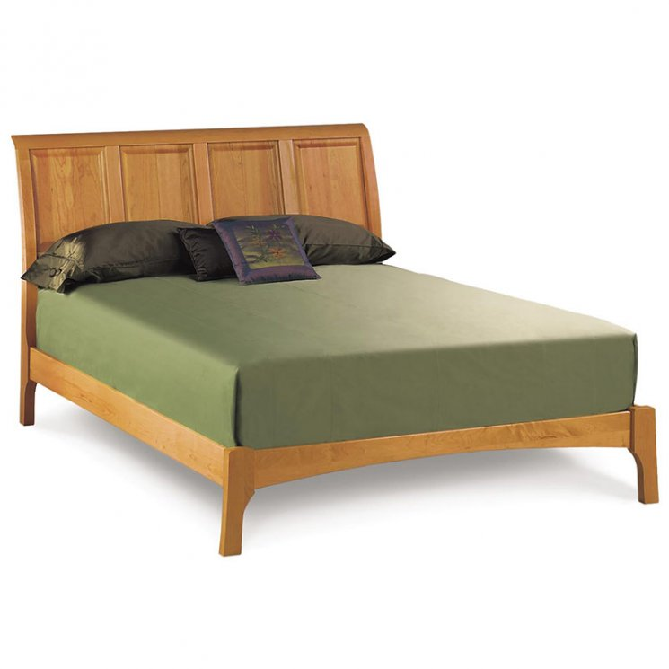

American Shaker design gives Copeland's Sarah Sleigh Bed with Low Footboard a clean look with elegant proportions. This luxury solid cherry wood platform bed features a large, inclined headboard and simple low footboard for ease when making the bed.